 | Broker Inquiries: Broker@businesshealthtrust.com or bht@badvprofessionals.com  Nice Inquiries: nice@businesshealthtrust.com  General: info@businesshealthtrust.com  Administration/Billing: BHT@vimly.com  Phone: (425)201-1972

Broker Quick Resource Guide
BHTguide.com | Business Health Trust

Support from BHT
OPEN ENROLLMENT | NICE HEALTHCARE | EMPLOYER MATERIALS
In person or virtual participation | In person or virtual orientations and Q&A | Care Kits and employee giveaways

Nice Healthcare (Direct Primary Care)
Included care that helps employees address routine needs and navigate next steps
DPC reduces insurance billing and administrative steps and eliminates employee copays and deductibles for included services. Nice offers primary and acute care, chronic condition management, mental health therapy, and virtual physical therapy with dedicated employed clinicians. Nice reports clinical access across 15 states and average in-app response times under 5 minutes.

DPC case-study comparison
MEASURE | TRADITIONAL PRIMARY CARE | DPC PAID DIRECTLY BY A PLAN LIKE BHT
Reported cost | $757 per person; $3,028 for a family of four | $500-$600 for a family of four
Provider time and visits | 12 minutes; 2.5 visits | 80 minutes; 2.5 visits; 80 text messages
Prescription costs | Not included in the reported cost | Includes 70–80% of daily prescription needs
These figures do not represent Nice Healthcare® pricing. Comparisons from Healthcare Transformation Alliance.

HTA findings cited in the case-study talking points
Health Transformation Alliance (HTA) is reports DPC reductions of at least 25% in each category: emergency room visits, hospitalizations, and specialist visits, together with more time spent with providers based on review of 1.3 million commercially insured patients receiving one of 38 CPT services appropriate for primary care.

New in January 2027 – Nice Healthcare®
EXPANSION | BROKER TALKING POINT
Labs and imaging | Virtual members can access 35 included lab tests and X-rays at local facilities, expanding access beyond in-person care.
Prescriptions and reach | 700+ included medications; virtual care expansion into additional states is planned. [1, 2]
Specialized care | One-to-one clinical coaching for diabetes, hypertension, weight management, and perimenopause / menopause.
Garner referrals | Included referrals to high-quality, in-network specialists. Nice reports average employer savings of $1,900 per referral.
Nice-reported results: $1,593 lower medical claims per employee per year • 92.0 overall NPS • 97.2% patient preference over prior clinic care. Results are reported averages, not guarantees.
PREMERA IHT


BHT’s Premera Blue Cross IHT plans
Underwritten | 2 employee minimum | 5% broker commission
JANUARY EFFECTIVE DATES | JULY EFFECTIVE DATES
Agriculture; Business Services; Community Service Organization; Construction; End Line Manufacturing; Information Technology; Retail; Wholesaling | Aerospace; Healthcare; Media; Tourism; Transportation

Included from BHT
WHO | BENEFITS AND SERVICES
Enrolled employee | $15,000 AD&D / life insurance.
Employee and benefit eligible dependents | Nice Healthcare; 6 EAP visits; $1 million Norton LifeLock identity protection and Passport Corporate Discount Program (employee activation required for both). Dependents are eligible even when not enrolled on the medical plan.
Employer | Archbright membership (policies, forms and HR hotline); Care Kits; consolidated billing with SIMON; COBRA administration.

Premera plan summary
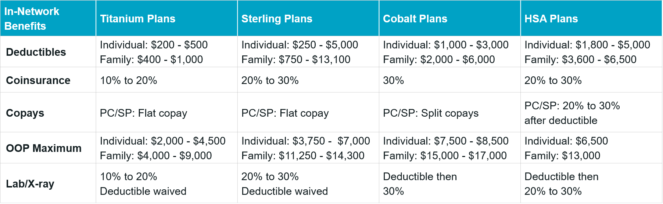

 | KAISER IHT SUMMARIES

BHT’s Kaiser Permanente IHT Plans
Underwritten | 2 employee minimum | 5% broker commission

JANUARY EFFECTIVE DATES | JULY EFFECTIVE DATES
Aerospace; Healthcare; Media; Tourism; Transportation | Agriculture; Business Services; Community Service Organization; Information Technology; Retail; Wholesaling

Included from BHT
WHO | BENEFITS AND SERVICES
Enrolled employee | $15,000 AD&D / life insurance.
Employee and benefit eligible dependents | Nice Healthcare; Nice Connect orientation with BHT required; 6 EAP visits; $1 million Norton LifeLock identity protection and Passport Corporate Discount Program (employee activation required for both). Dependents are eligible even when not enrolled on the medical plan.
Employer | Archbright membership (policies, forms and HR hotline); Care Kits; consolidated billing with SIMON; COBRA administration.

Kaiser IHT plan summaries
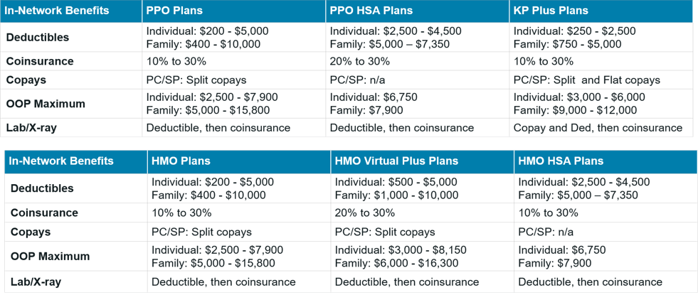
Kaiser IHT PPO and HMO plan overview

KAISER SMALL GROUP

Kaiser Permanente Small Group Plans
Group size: 2–50

Included from BHT
WHO | BENEFITS AND SERVICES
Employee and benefit eligible dependents | Nice Healthcare (employer activation required); Nice Connect orientation with BHT required; Passport Corporate Discount Program (employee activation required). Dependents are eligible even when not enrolled on the medical plan.
Employer | Archbright membership (policies, forms and HR hotline); Care Kits; consolidated billing with SIMON; COBRA administration available.

Small group plan summaries
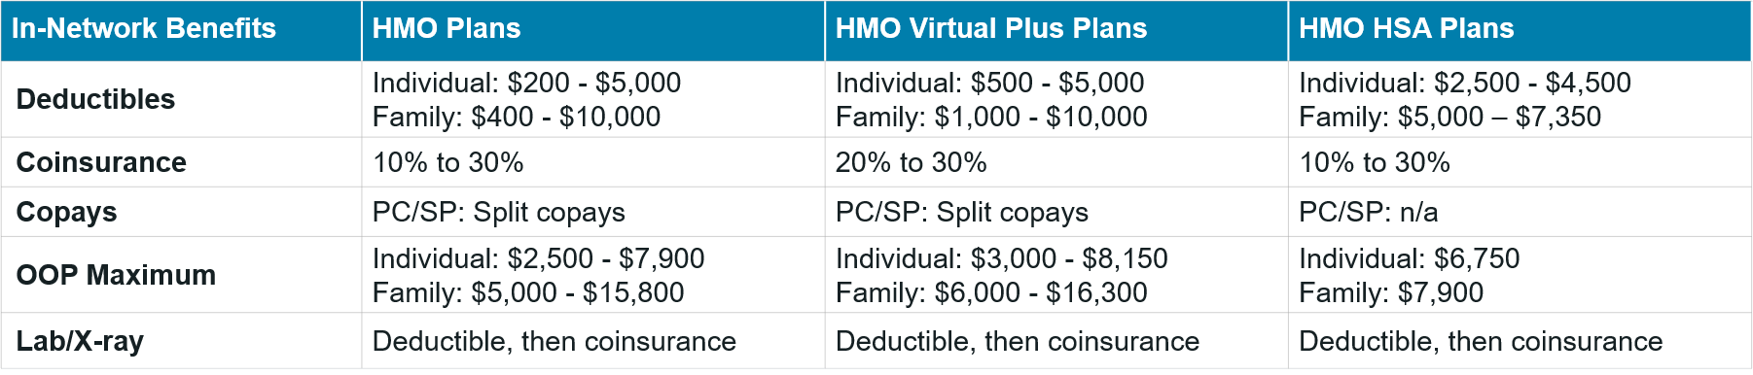
HMO, HMO Virtual Plus, and HMO HSA plans
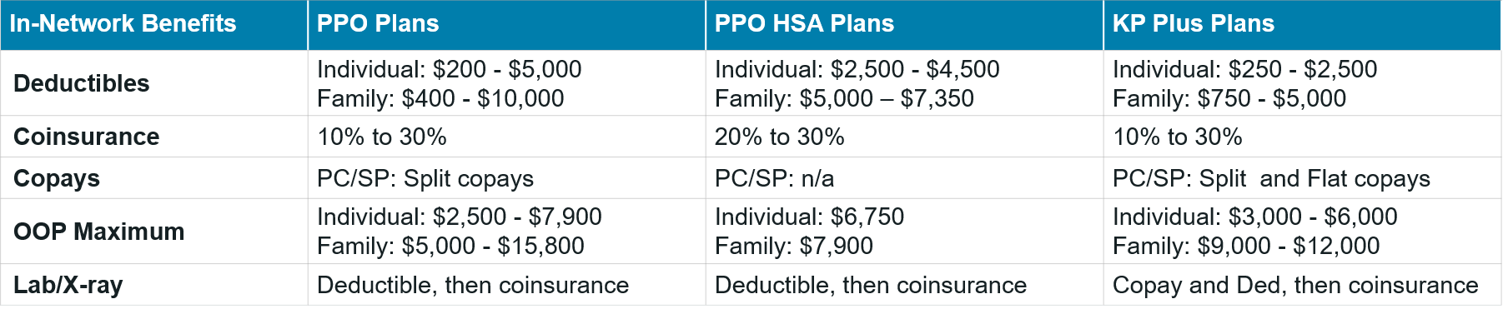
PPO, PPO HSA, and KP Plus plans

PPO NETWORK AND ANCILLARY

Kaiser PPO Network and Ancillary Benefits
Network information for Kaiser IHT and Kaiser small group PPO plans

Options and Access PPO network
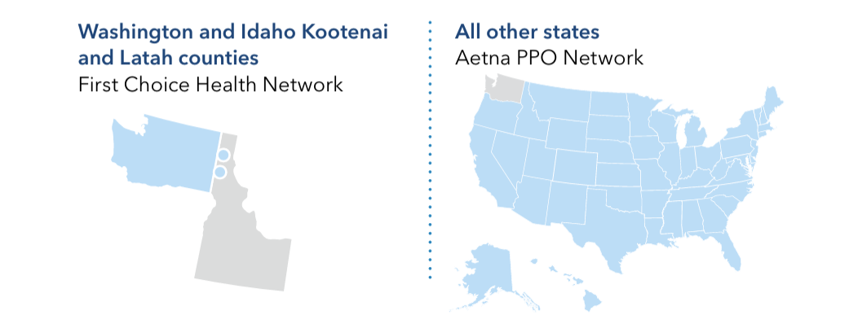
Aetna Administrators Signature Network
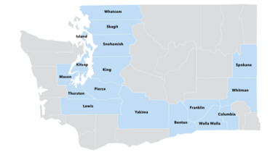
Washington county map supplied for Kaiser IHT plans

Ancillary benefit carriers
AVAILABLE PARTNERS | ADDITIONAL SUPPORT
Delta Dental • USAble Life • VSP | Norton LifeLock Benefit Solutions • AIG • Telus Health (EAP)

Included with ancillary benefits
WHO | BENEFITS AND SERVICES
Employee and benefit eligible dependents | Passport Corporate Discount Program (employee activation required), even when dependents are not enrolled on a plan.
Employer | Archbright membership (policies, forms and HR hotline); consolidated billing with SIMON; COBRA administration available.

