Timing: Two Weeks after “Live” Date for Employer

Hi Team,

I wanted to remind you that our new NICE Healthcare® access has started! Remember, you can sign up here and then start accessing care ASAP.
Our contact at BHT recommends scheduling an appointment in the next week or so, if you have any medications that NICE offers (or over the counter allergy medications, for example), you can stop paying for them (there’s no deductibles, no co-pays --- $0 for medications).

I’ve also attached some materials for you!
- Flyer: How to Sign Up
- Checkout BHT’s favorite part of NICE
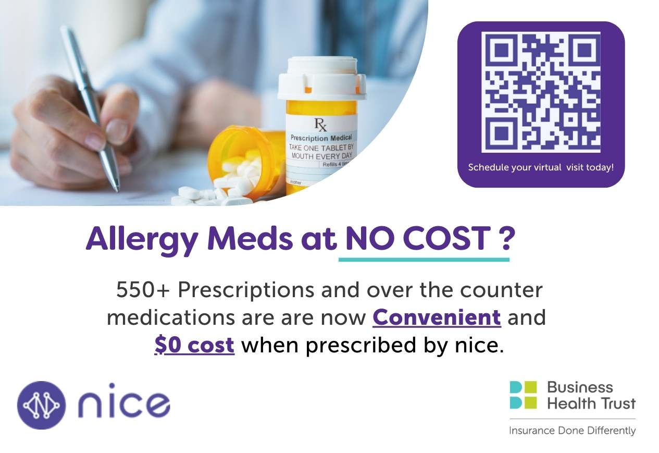
If you have any questions that come up, please feel free to reach out to BHT at nice@businesshealthtrust.com.

